**Project documentation for *Cents: put sense into your finances* mobile app**

**Overview of the process**

The goal of our project was to address the overwhelming complexity of the usual budgeting apps and to create something that is straightforward with a clear spending visualisation for the user. We hope this would help people, especially those just starting out with budgeting, to take ownership of their finances and stick to their intended budget. Starting out we faced the challenge of creating a project that is functional and self-contained without overcomplicating either the UI or the programmatical aspect. We already have many ideas on how we would love to improve and expand this app – with appropriate increase in time and skill.

Another issue we faced was the difference in schedules and time zones making it difficult for all of us to meet regularly and discuss the project. We overcame this by sharing notes from the meeting enabling those of us who missed the to continue being in the loop both with their own tasks and the overall progress of the group.

**Goals and Design choices**

Our goals for this app were to further our understanding of React and Redux, as well as the design decisions involved in making a mobile app. We wanted to create something that showcased our dedication to simplicity and ease of use while still achieving high functionality and interesting design.

Who did we design the app for?

When designing our app, we imagined a young woman who is already comfortable with technology but is new to budgeting. She might have been motivated to start budgeting by the current cost of living crisis, or a desire to take charge of her finances in pursuit of independence and savings. She wants to live within her means and, if possible, to save for future investments (such as property). She is frustrated that she often doesn’t have the motivation to stick to her budgeting goals in face of tempting offers or good deals. She often impulse buys. She wants to have an all-in-one accessible tool which will keep her accountable by having to write the numbers down and will showcase her spending habits by seeing the money she is putting into each of her spending categories. She has quite a few apps on her phone so is looking for something lightweight, without much fuss.

**Design choices**

In order to help our user to achieve these goals we offer a simple non cluttered interface that allows for putting expenses into categories. We incentivise staying within the predicted budget by portraying motivational messages at login screen. We would love to implement an option to share your budget goals with friends in order to promote accountability.

**Colour palette and imagery**

Primary colour

We chose soft, muted colour palette with prominent grey element to inspire calmness. User experience research shows grey inspires feelings of peace and indicates restraint. These are features we wished to convey to the user. The primary pink-grey colour we chose for our app is reminiscent of the Pantone colour of the year, with more softness and stronger grey influence. Through this, we ensure our app has a distinct look with recognisable colours while maintaining a modern feel that aligns it with other apps and websites of the year 2023. We guard against potentially moody or depressing appearance of the app by using a generally regarded positive colours such as pink and blue to balance the grey.

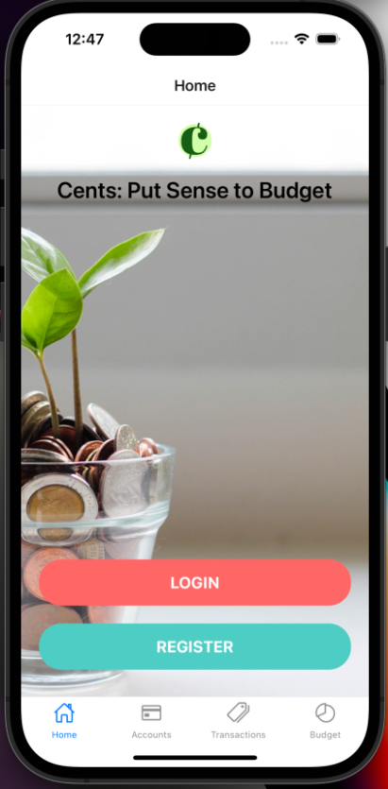

Login background picture of a plant growing from a pot of coins also signals monetary growth as well as inspires feelings of positivity and calmness. It has been repeatedly proven in psychological research that sights of greenery and plants reduce stress levels and promote positive feelings even when the pictures are seen briefly on computer screens. The plant also serves to bring colour green into the app tying it to our logo.

**Logo**

During the design process we aimed to encapsulate the central aims and goals of our app, as well as its aesthetic. A balance between including all that a product stands for and adding too many elements of interest was crucial for us in the design of a logo. As such, we opted for monetary elements and a representation of the name. Combination of the letter C with features of currency symbols such as dollar or euro is a simple and elegant solution conveying this is a budgeting app without overcomplication. It features a combination of muted green colours with the pink-grey form the app colour palette thus tying the app and the logo together while adding some warmth into the otherwise cold spectrum prominent in the app.

**User Journey**

**Functionality**

We started with quite a complex wireframe of the features we would like to include in the app. After team discussion and taking our constraints into consideration opted for a simpler version of the app which maintains the core concepts. Initially we wished to model the spending and show spending prediction. However, we opted for a simpler approach due to the complexity of mocking and modelling required for such a feature.

**Features**

**Implementation**

React and Redux